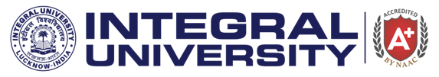

**Report on Guest Lecture by Dr Sudip Chaudhary**

**Date: 25th August 2023**

**Venue: D113, Block-D, Integral University**

The Department of Chemistry, Integral University, organized an insightful guest lecture on **25th August 2023** on the topic “**Stimulate Your Will Power**,” delivered by **Dr. Sudip Chaudhary, Assistant Professor at Isabella Thoburn Degree College, Lucknow**. The event aimed to motivate students by addressing the importance of willpower in both academic and personal growth. Dr. Chaudhary began the lecture by defining willpower as the ability to resist short-term temptations in order to meet long-term goals. He emphasized the role of self-control, discipline, and mental strength in overcoming obstacles, both academic and personal.

Following the lecture, Dr. Chaudhary engaged with the students in an interactive Q&A session. Students posed insightful questions regarding challenges they face in maintaining discipline and staying focused on their academic pursuits. Dr. Chaudhary addressed their concerns with practical advice, encouraging students to prioritize consistency over perfection and to view setbacks as opportunities for growth. The lecture concluded with a vote of thanks delivered by Dr. Saimah Khan, Associate Professor, Department of Chemistry, Integral University, Lucknow. Dr. Chaudhary was praised for his inspirational talk, which left a lasting impact on the students, motivating them to strengthen their willpower in their academic journey and beyond. The lecture was attended by more than 50 students and the faculty members.

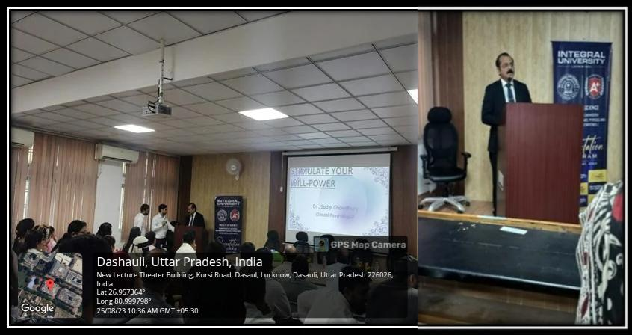**Glimpse of the Event:**